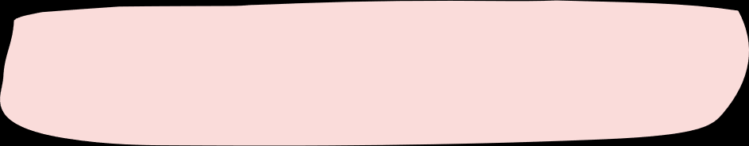

|  |  |  |  |  |
| --- | --- | --- | --- | --- |
|  | | | | |
| Certificate for ĄĆDEĘFGHIJKLŁMNŃOÓPQRSŚTUVWXYZŹŻ | | | | |
| Best in the world | | | | |
| 012345678901 | | | | |
| in recognition of being the best! | | | | |
|  | Signature |  | June 6, 2024 |  |
| Payton Davis, Neighbor | Date |